Week 2
Worksheet Experiment:1; Syed Sualeh Abbas 10303
“To Prepare Slides of Onion Cells, and Cheek Cells”
Total Marks (30 Marks):
1) Lab performance (10 Marks):
2) Observations (4 marks):
 | Microscopy  (Attach picture of stained and unstained cells) | Morphology  (Shape, arrangement, organelles)
Part:1  Unstained Onion Cells  Stained Onion cells | 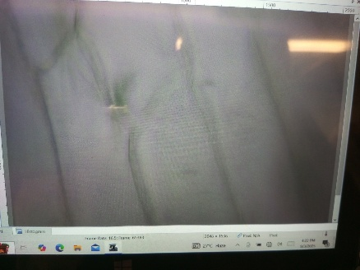  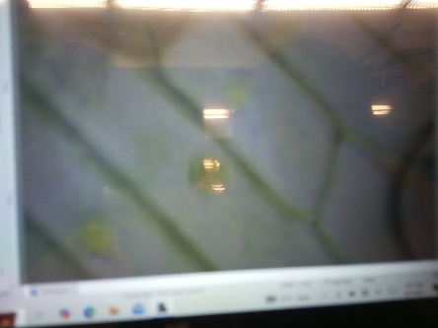 | The shape of cell looks definite, and cell walls are clearly visible, but nucleus is not visible under microscope.  It this picture, due to its stained, the nucleus is also visible, shape is definite rectangular and cells are arranged packed side by side of each other.
Part:2  Unstained cheek Cells  Stained cheek cell | 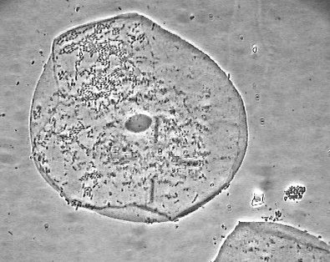  Picture from internet.  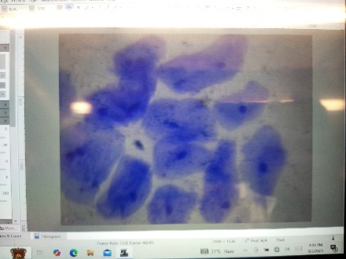 | As it is a cheek cell, it has no regular shape, Nucleus and other organelles are visible. Shape is rounded and cells are not packed with each other.  Multiple cells are packed at the same place and as it is stained, nucleus is clearly visible as the darker blue dot. They are off irregular shape and sizes.

3) Result (2 Marks):
According to the observation of Onion cells under the microscope, we have observed that the onion cells have rectangular shape, and multiple organelles such as nucleus, vacuole and other cell organelles were present.
According to the observation of Cheek cells under the microscope, we have observed that the cheek cells have irregular shape, and Nucleus and other cell organelles were present.
The purpose of my experiment was to observe onion cell and human cheek cell under a microscope in both stained form and unstained form. If we compare 2 types of cells, we observe the differences such as Shape of cell, Size of cell, Size of organelles and etc.
4) Question (4 Marks):
- Describe the differences observed between stained and unstained cells for both cell types, and explain the effects of different microscope magnifications on their appearance.
  - The most significant difference in stained and unstained cells was in observation, we were able to easily observe the cell and the nucleus of stained cells of both plants and cheek, but in case of unstained, cheek cell was not visible under microscope and we were not able to observe the nucleus of plant unstained cell
- List the names and functions of the organelles observed in plant cells and animal cells.
  - Nucleus:- It gives instructions to all organelles to perform a specific task meanwhile it also stores genetic information of the cell.
  - Cell wall:- It keeps the cell in shape and acts as a protective semi-permeable membrane to ensure only allowed chemicals enter the cell.
- Explain why certain organelles are not visible in animal cells but are present in plant cells.
  - Cell wall:- its not present in animal cell. Keeps plant cells in shape.
  - Large central vacuole:- Plants cell have a big vacuole, taking up almost all space in the cell, however, animal cells have small many vacuoles which were not visible under microscope.

- Write four points you learned from the Labster simulation.
  - Learned the difference between prokaryotic and eukaryotic cells.
  - Learned the different organelles and which are present in only animal cell or plant cell.
  - Learned the basic function of most of the organelles.
  - Learned about the cell theory and history of discovery of cells.
5) Labster Simulation (10 Marks):
6) Errors/Problems:

